Jonathan Nusantara and Jiaxuan Su

Object tracking mobile robot:  
A robot will be tracking and following a rolling ball. The robot from lab 3 will be used as the base mobile robot. It will use a Pi Camera to perform computer vision to recognize the ball and to follow the moving ball. The motor speed will depend on the distance of the ball from the robot. Hand gestures (showing digits) will be used to control the robot to stop or continue to track the ball (and perhaps additional controls or modes may be created). The PiTFT will also display a menu to start/stop tracking. Accelerometer may be integrated to calculate the distance travelled and current speed, which can then be displayed in PiTFT. (We are open to any changes that can make this project “more useful” for human’s life)

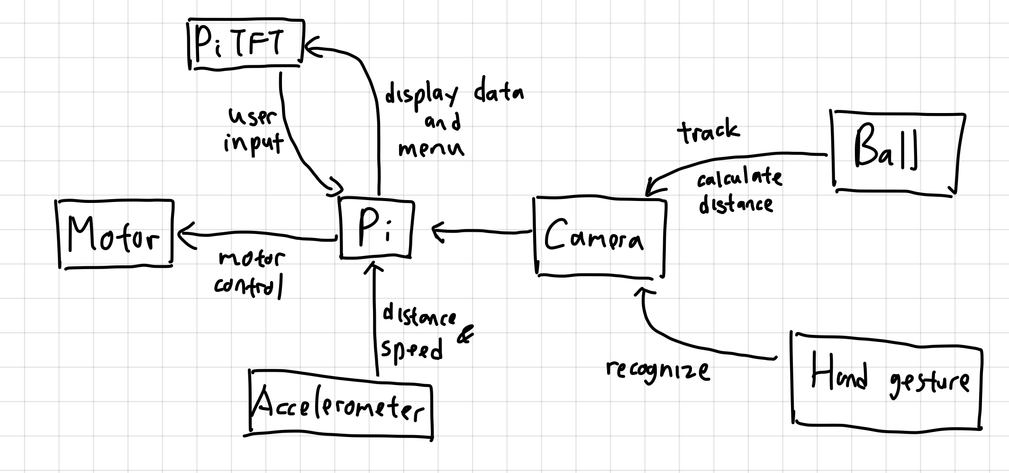

Might be able to track a ball that reflects off something when bouncing.

Make sure that it can track straight and when moving/reflect off something.

Gimbal for the camera.

Maybe moving cart in groceries

Employee time-clock using face recognition:  
The goal is to have a system that allows a user or employee to clock-in and clock-out. The Pi camera will be used as input for a live video feed and OpenCV will be used to perform facial recognition. The face captured will then be compared using a machine learning algorithm to the list of employees faces. The PiTFT will be used to display a menu to clock-in, clock-out, or to register a new employee. When registering a new employee, the PiTFT will guide the employee to capture several photos of themselves to be saved/used as training data. The clock-in clock-out data will be saved in a spreadsheet, which can then be sent via email by pressing the “extract data” button in the PiTFT. (We are open to any other facial recognition project ideas).

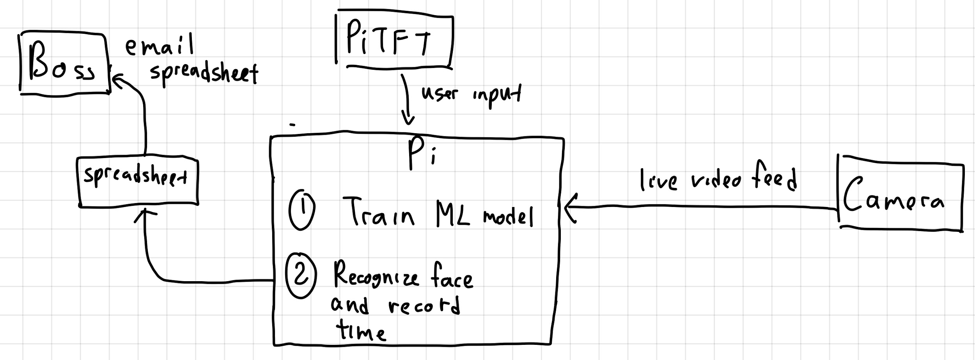

Facial recognition in Pi3 is limited to a few faces, and cannot have a giant database.

For clock-in clock-out data, maybe information can be uploaded periodically somewhere. Need a bit more of an expansion.

Maybe have the robot fixed and have the robot to pick up objects in front of it.